Laporan Praktikum 1

Nama : Fakhrul Anam

Kelas : 5A

NIM : 18090113

1. Source code

Perkenalan.php 🡪 application/controller

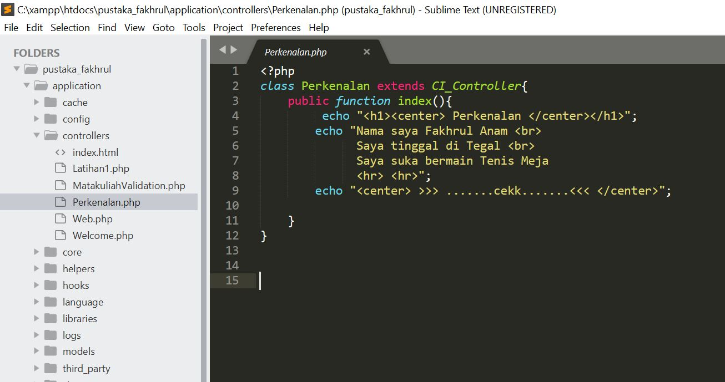

1. Capture Output Program

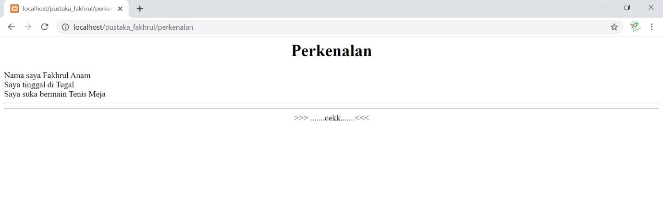

1. Url

<http://localhost/pustaka_fakhrul/perkenalan>